# Abstract

* In our project we are going to using the basic as well as the object-oriented language (OOP) techniques of C++ as well as an external language of C++ know as Simple and Fast Multimedia library (SFML). In our project we used different techniques from SFML and C++ to create a small game on window rather then on the console of visual studio. we created animation that move and get destroyed on a certain condition and the player gain some point when ever the player kill/destroy the enemy animation.

# Introduction of your project

# We have designed a 2d game, which shows the medieval era where a hero (human) stands against the dark lord (who is the mastermind behind all the evil) for humanity. At first, the hero fights all the minions (common enemy) of the dark lord. After defeating the common enemies, the hero faces the dark lord (main boss). There is going to be a mechanism of health which will tell who has won the battle. There is also going to be a scoring mechanism that is going to give the player score for beating each enemy he faces throughout his journey against the dark lord.

# Problem Statement

* Our project is about game development or the implementation of animations/images using concept of OOP in C++.
* We are doing this project so that we ca learn more advance use of C++ and its libraries and to get to know how we can do programming outside of the console and create a window and do some tasks there.

# Methodology/ Plan development to solve the Problem

* We are going to perform our project by using some simple conditions loops and some advance techniques that are going to be inherit from SFML. We are going to use SFML (GRPHICS, WINDOW) library to perform our project. We are also going to use the major concepts of OOP like encapsulation inheritance.
* We are going to divide our project in to 5 classes which are:  
  1) Enemy class.

2) Hero class.

3) Animation class.

4) Health class.

5) Time class.

6) Game1 (main file).

* Every class must give a specific outcome which it will achieve by performing different functions and operations to give the desired outcome.

# Specifications

We have used the following specifications in our program:

* Simple and fast multimedia library.

1)SFML Windows.

2)SFML Graphics.

3)SFML System.

4)SFML Clock.

5)SFML Time.

* Inheritance.
* Encapsulation.
* Abstraction.
* Condition loops.
* Input statements.
* Output statements.

# Results Discussion

* Expected output:
  + In a particular scenario when the hero kills the enemy, he will be awarded 10 points.
  + If the enemy crosses a specific position (defined by coordinate-{-1}on x-axis) hero will lose half heart(health), when 11 enemies crosses the specific position hero will lose all his hearts and the game will eventually end and the hero will lose the game.
  + If the hero can hold the enemies for 2 minute that means the enemy does not cross the specific position, then the hero will win the game and the game will end.
* Discussion:
  + At first when the program run the console will open with the game controls mentioned on it. When the user will enter his/her name and press enter the game will start.

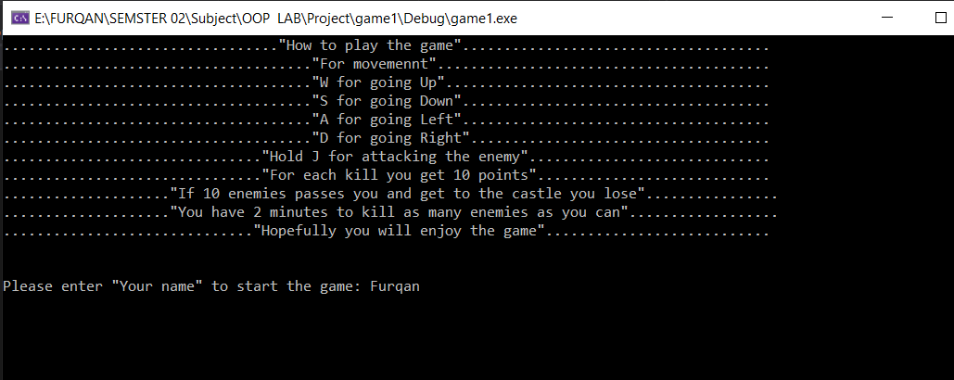

* + When the user press enters the game will start and a new window will open with hero and enemy’s animation as well as the animation of health and time animation.

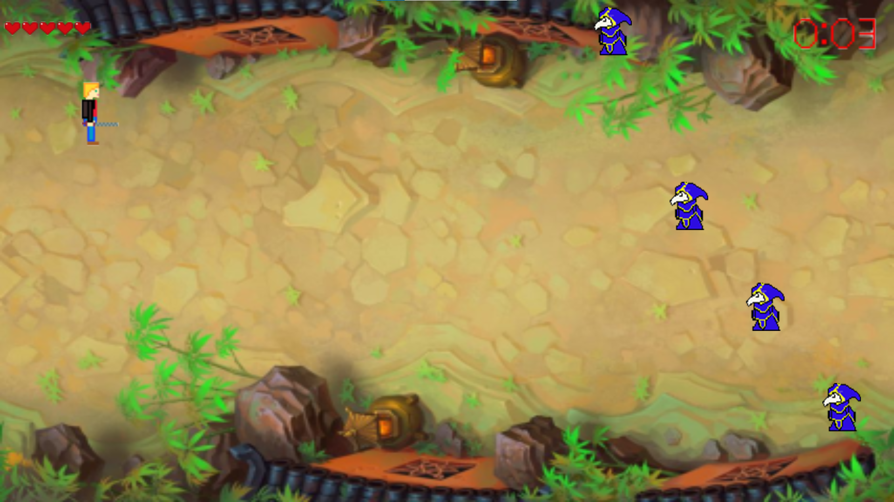

* + Hero can move forward, upward, to left side and right side with the help of W, S, A, D keys from the keyboard.
  + When hero moves near the enemy and the user press “J” key the enemy will get killed.

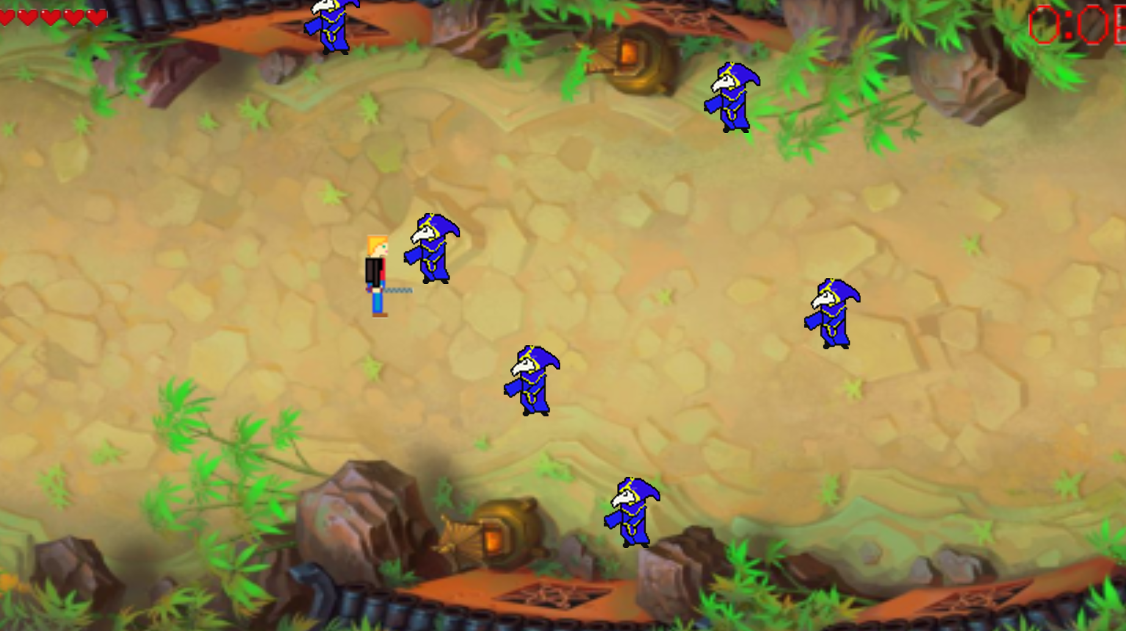

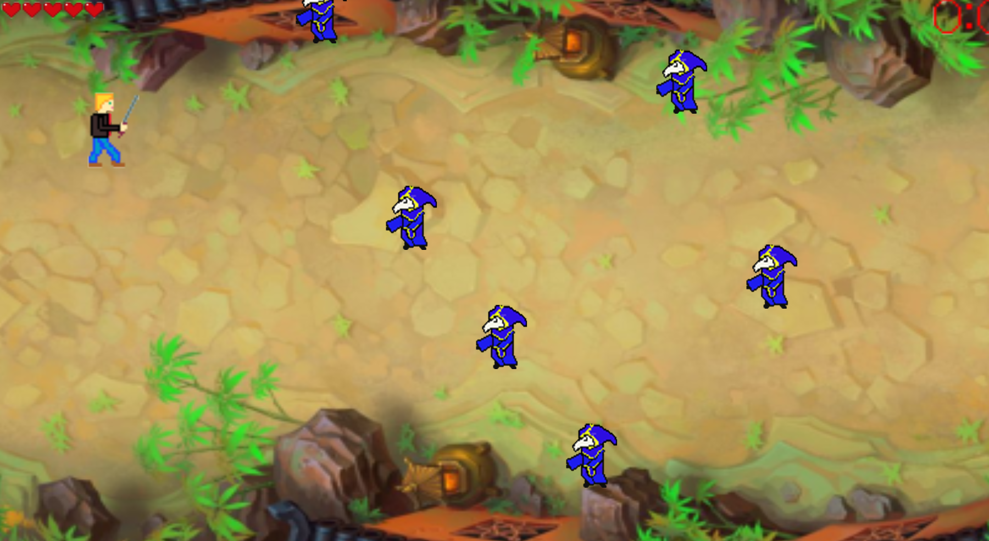

* + When the enemy cross the left side of the screen hero will loss a hearts/health.

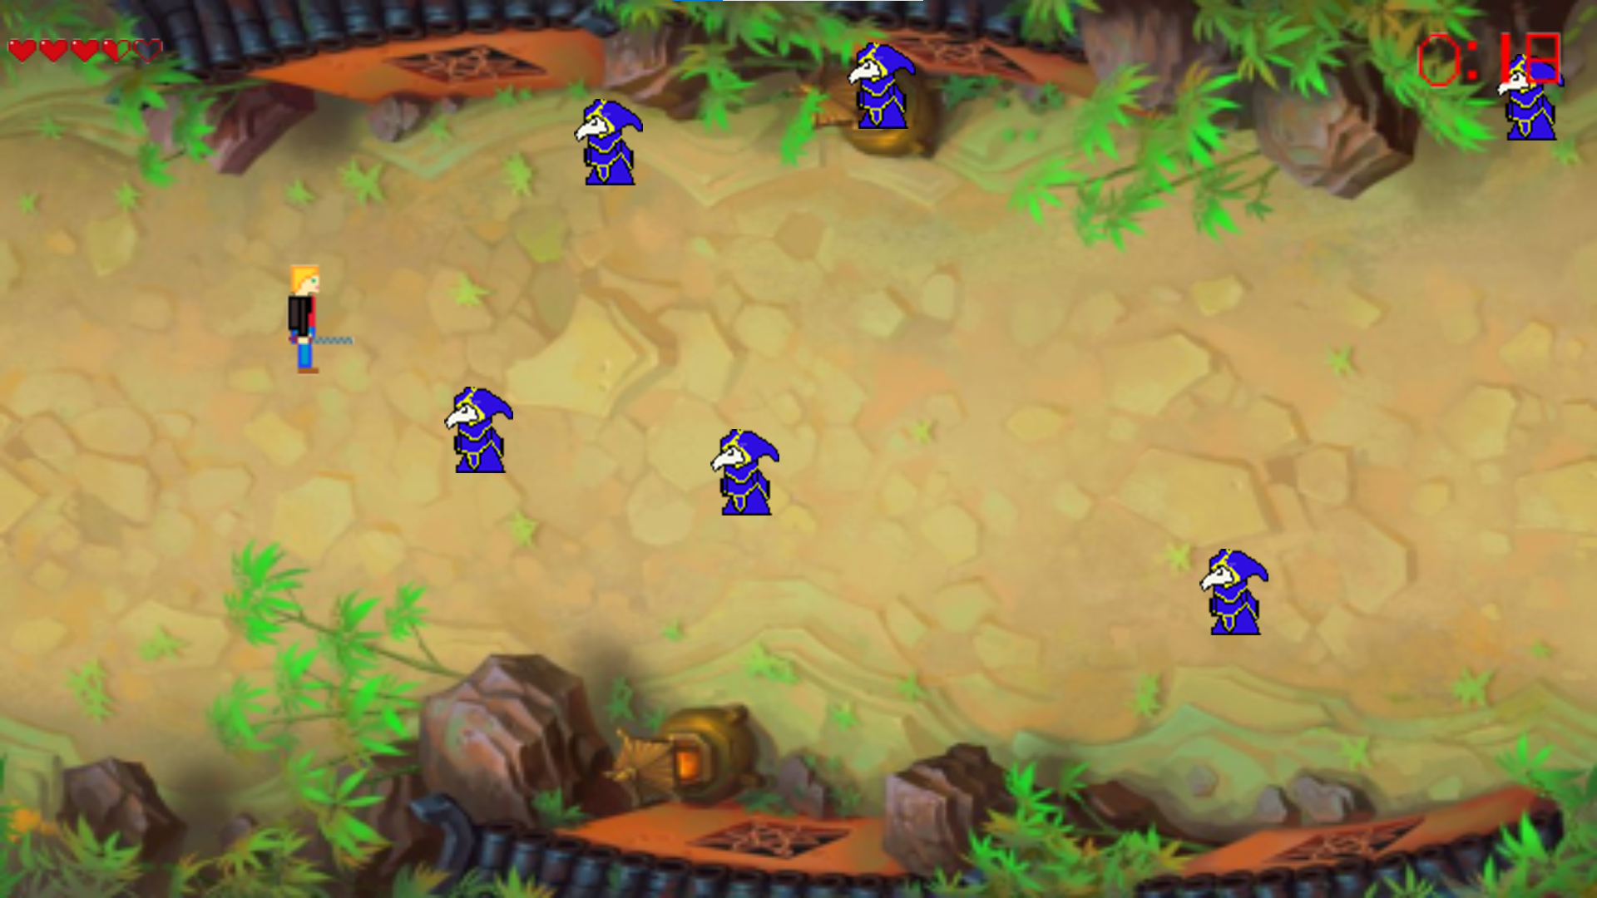

* + When the time that is shown on the top right of the screen reaches 2:00 the game will end, and the hero will win the game.
  + In the end of the game hero will either win or loss the game and points will be shown on the screen.

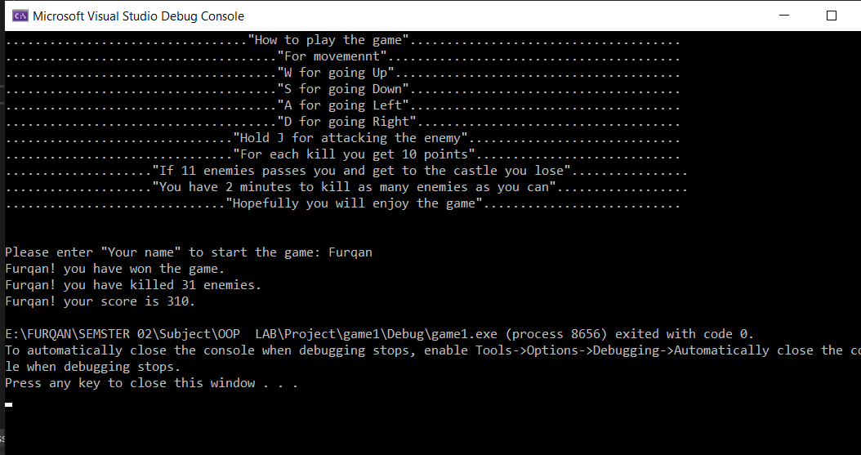

# Conclusion

* Important details/outcomes:
  + We successfully designed a 2 D game with the help SFML and the core concepts of Object-oriented programming. Our project consists of different libraries of SFML that help us to successfully create our game.
  + Our game game has system to produces moving objects on the screen and destroy them on certain conditions we also made a health concept for our hero so that the game can have some condition in which the hero loss/win the game.
  + Whenever the user kills an enemy, he is awarded 10 points which are shown in the end of the game.
  + There is also a time limit condition which determine that the hero have won the game or has loosed it.
* Improvement:
  + We can further improve our project/game by introducing the concepts of hit detection and collision that will determine when the enemy will be killed and when the hero will loss his health when the enemy collied with the hero.

# References

* 2019. *SFML - Visual Studio Setup (C++ Tutorial)*. [video] Available at: <https://www.youtube.com/watch?v=YfMQyOw1zik> [Accessed 9 May 2021].
* 2021. *SFML 2.4 For Beginners*. [video] Available at: <https://www.youtube.com/playlist?list=PL21OsoBLPpMOO6zyVlxZ4S4hwkY_SLRW9> [Accessed 1 April 2021].
* 2021. *[ C++ & SFML - Simple 2D Games ] - GAME 1 / PART 1 - Creating the window.*. [video] Available at: <https://www.youtube.com/watch?v=C06eGdy7C6k&t=2s> [Accessed 1 May 2021].
* 2021. *C++ & SFML Tutorial 2D Platformer Video Game*. [video] Available at: <https://www.youtube.com/playlist?list=PL2RPjWnJduNlK7KsW2PJXoYDEdp539WIr> [Accessed 1 April 2021].
* Haller, J., Vogelius Hansson, H. and Moreira, A., 2019. *SFML Game Development*.
* Sfml-dev.org. 2021. *SFML*. [online] Available at: <https://www.sfml-dev.org/> [Accessed 5 April 2021].